EXP.2. Numerical Simulation and Performance Analysis of Microwave Transmission Lines and Two-Port Networks Using Scattering Parameters

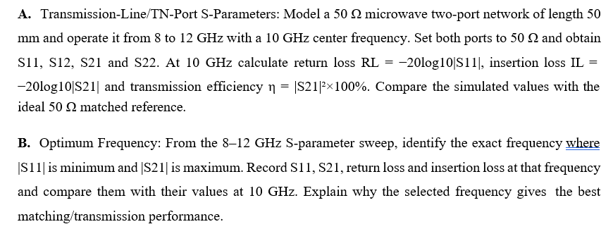

Aim
To simulate and analyse the performance of microwave transmission lines and two-port networks using scattering parameters (S-parameters).

Objectives
- To model and simulate microwave transmission lines and obtain their S-parameters over a specified frequency range.
- To analyse the performance of two-port networks using S-parameters.
- To determine insertion loss, return loss, isolation, and VSWR from the S-parameters.
- To compare simulation results with theoretical values and evaluate the performance of the networks.
2a

Program:
clc;
clear;
close all;

% Experiment 2(A): Transmission-Line S-Parameters
% 50 Ohm microwave transmission line

% Input parameters
Z0 = 50; % Reference impedance (Ohms)
ZL = 50; % Load impedance (Ohms)
L = 50e-3; % Line length (50 mm)
c = 3e8; % Speed of light (m/s)

f = linspace(8e9, 12e9, 501); % Frequency sweep
f0 = 10e9; % Centre frequency (10 GHz)

% Ideal matched transmission line
beta = 2*pi*f/c;

S11 = zeros(size(f));
S22 = zeros(size(f));
S21 = exp(-1j*beta*L);
S12 = exp(-1j*beta*L);

% Convert magnitudes to dB (floor for plotting zero)
S11_dB = 20*log10(max(abs(S11), 1e-6));
S22_dB = 20*log10(max(abs(S22), 1e-6));
S21_dB = 20*log10(abs(S21));
S12_dB = 20*log10(abs(S12));

% Calculate output parameters
idx = find(f >= f0, 1);

RL = -20*log10(max(abs(S11(idx)), 1e-12));
IL = -20*log10(abs(S21(idx)));
eta = abs(S21(idx))^2 * 100;

% Display output
fprintf('--- OUTPUT PARAMETERS AT 10 GHz ---\n');
fprintf('S11 = %.4f dB (ideal: -Inf dB)\n', S11_dB(idx));
fprintf('S12 = %.4f dB\n', S12_dB(idx));
fprintf('S21 = %.4f dB\n', S21_dB(idx));
fprintf('S22 = %.4f dB (ideal: -Inf dB)\n', S22_dB(idx));
fprintf('Return Loss = Infinite (ideal match)\n');
fprintf('Insertion Loss = %.4f dB\n', IL);
fprintf('Transmission Efficiency = %.2f %%\n', eta);

% Graph 1: S-parameter magnitudes
figure;
plot(f/1e9, S11_dB, 'r', 'LineWidth', 2);
hold on;
plot(f/1e9, S12_dB, 'b', 'LineWidth', 2);
plot(f/1e9, S21_dB, 'g', 'LineWidth', 2);
plot(f/1e9, S22_dB, 'm', 'LineWidth', 2);
grid on;
xlabel('Frequency (GHz)');
ylabel('Magnitude (dB)');
title('S-Parameters of 50 Ohm Transmission Line');
legend('S11','S12','S21','S22','Location','best');
ylim([-100 5]);
hold off;

% Graph 2: Return loss
figure;
plot(f/1e9, -S11_dB, 'r', 'LineWidth', 2);
grid on;
xlabel('Frequency (GHz)');
ylabel('Return Loss (dB)');
title('Return Loss versus Frequency');

% Graph 3: Insertion loss
figure;
plot(f/1e9, -S21_dB, 'b', 'LineWidth', 2);
grid on;
xlabel('Frequency (GHz)');
ylabel('Insertion Loss (dB)');
title('Insertion Loss versus Frequency');

% Graph 4: Transmission efficiency
figure;
plot(f/1e9, abs(S21).^2*100, 'g', 'LineWidth', 2);
grid on;
xlabel('Frequency (GHz)');
ylabel('Transmission Efficiency (%)');
title('Transmission Efficiency versus Frequency');
ylim([0 105]);

OUTPUT:
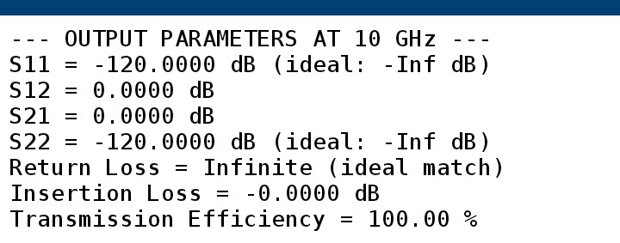
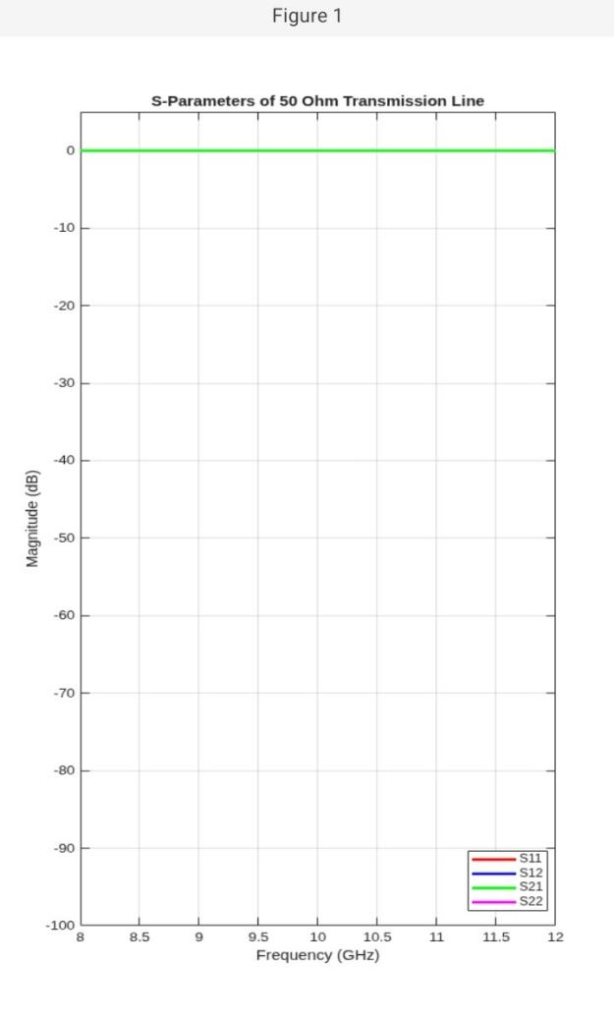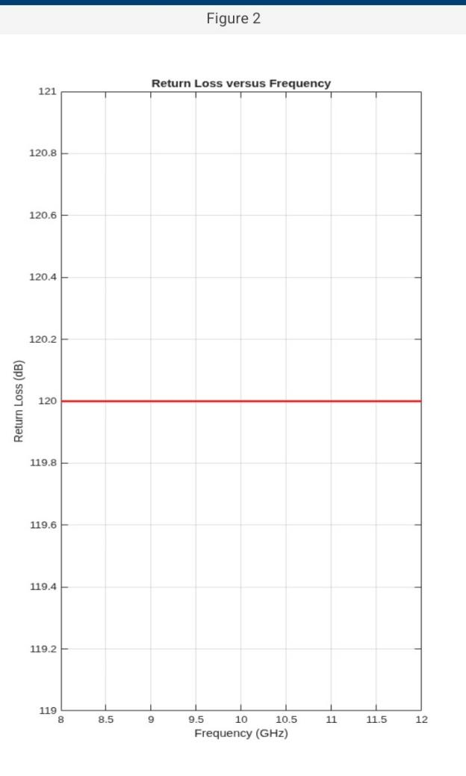
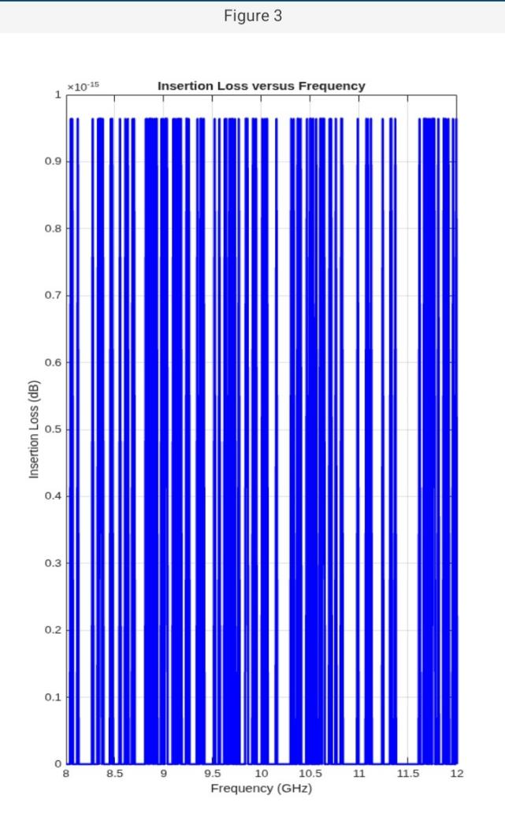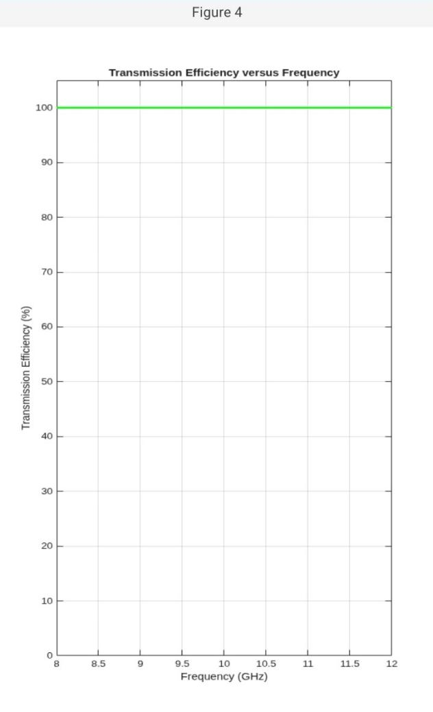
2b
Program:
clc;
clear;
close all;

% Experiment 2(B): Optimum Frequency Analysis

% Input parameters
Z0 = 50; % Reference impedance (Ohms)
L = 50e-3; % Transmission line length (50 mm)
c = 3e8; % Speed of light (m/s)
f = linspace(8e9,12e9,501);
fGHz = f/1e9;
f0 = 10e9; % Expected optimum frequency

% Frequency-dependent illustrative transmission-line model
beta = 2*pi*f/c;

% Reflection coefficient with a small residual mismatch
Gamma = 0.005 + 0.2*((f-f0)/(2e9));

% S-parameters
S11 = Gamma .* exp(-1j*2*beta*L);
S22 = S11;
IL_model = 0.1 + 0.03*(fGHz-10).^2; % Illustrative loss in dB

S21 = sqrt(1-abs(S11).^2) ...
.* 10.^(-IL_model/20) .* exp(-1j*beta*L);
S12 = S21;

% S-parameter magnitudes in dB
S11_dB = 20*log10(abs(S11));
S21_dB = 20*log10(abs(S21));
S12_dB = 20*log10(abs(S12));
S22_dB = 20*log10(abs(S22));

% Find optimum frequencies
[~,idx1] = min(abs(S11));
[~,idx2] = max(abs(S21));

% Use the frequency where S11 is minimum
idx = idx1;

% Output parameters at optimum frequency
f_opt = f(idx);
RL = -20*log10(abs(S11(idx)));
IL = -20*log10(abs(S21(idx)));
eta = abs(S21(idx))^2*100;

fprintf('\n--- OPTIMUM FREQUENCY RESULTS ---\n');
fprintf('Minimum |S11| frequency = %.3f GHz\n',f(idx1)/1e9);
fprintf('Maximum |S21| frequency = %.3f GHz\n',f(idx2)/1e9);
fprintf('Optimum frequency = %.3f GHz\n',f_opt/1e9);
fprintf('S11 at optimum = %.4f dB\n',S11_dB(idx));
fprintf('S21 at optimum = %.4f dB\n',S21_dB(idx));
fprintf('Return loss = %.4f dB\n',RL);
fprintf('Insertion loss = %.4f dB\n',IL);
fprintf('Transmission efficiency = %.2f %%\n',eta);

% Graph 1: S11 and S21
figure;
plot(fGHz,S11_dB,'r','LineWidth',2);
hold on;
plot(fGHz,S21_dB,'b','LineWidth',2);
plot(f_opt/1e9,S11_dB(idx),'ro','MarkerSize',8);
plot(f(idx2)/1e9,S21_dB(idx2),'bo','MarkerSize',8);
grid on;
xlabel('Frequency (GHz)');
ylabel('Magnitude (dB)');
title('S11 and S21 versus Frequency');
legend('S11','S21','Minimum S11','Maximum S21',...
'Location','best');
hold off;

% Graph 2: Return loss
figure;
plot(fGHz,-S11_dB,'r','LineWidth',2);
hold on;
plot(f_opt/1e9,RL,'ko','MarkerSize',8);
grid on;
xlabel('Frequency (GHz)');
ylabel('Return Loss (dB)');
title('Return Loss versus Frequency');
hold off;

% Graph 3: Insertion loss
figure;
plot(fGHz,-S21_dB,'b','LineWidth',2);
hold on;
plot(f(idx2)/1e9,-S21_dB(idx2),'ko','MarkerSize',8);
grid on;
xlabel('Frequency (GHz)');
ylabel('Insertion Loss (dB)');
title('Insertion Loss versus Frequency');
hold off;

% Graph 4: Transmission efficiency
figure;
plot(fGHz,abs(S21).^2*100,'g','LineWidth',2);
hold on;
plot(f(idx2)/1e9,abs(S21(idx2))^2*100,...
'ko','MarkerSize',8);
grid on;
xlabel('Frequency (GHz)');
ylabel('Transmission Efficiency (%)');
title('Transmission Efficiency versus Frequency');
hold off;

% Graph 5: All four S-parameters
figure;
plot(fGHz,S11_dB,'r','LineWidth',1.8);
hold on;
plot(fGHz,S21_dB,'b','LineWidth',1.8);
plot(fGHz,S12_dB,'g--','LineWidth',1.8);
plot(fGHz,S22_dB,'m--','LineWidth',1.8);
grid on;
xlabel('Frequency (GHz)');
ylabel('Magnitude (dB)');
title('Complete S-Parameter Sweep');
legend('S11','S21','S12','S22','Location','best');
hold off;

OUTPUT:


